- INTRODUCTION
This report analyzes restaurant and rating data to understand consumer preferences, market demographics, potential demand and supply gaps, and investment opportunities within the restaurant industry.

- DATA OVERVIEW

The analysis is based on restaurant attributes and customer ratings. Pivot tables and charts were used to summarize demographic patterns and identify trends.

- FINDINGS AND ANALYSIS

3.1 Highest Rated Restaurants (Question 1)
Analysis of the highest rated restaurants shows that customer satisfaction is strongly influenced by consistent food quality, services, and overall dining experience. Restaurants that align closely with customer preferences tend to receive higher ratings, indicating that customer’s preferences have a direct impact on ratings.

3.2 Consumer Demographics (Question 2)
Consumer demographic analysis shows that restaurants are concentrated in major cities, indicating higher demand in urban areas. Most restaurants operate within the low to mid-price range, suggesting affordability is an important factor for consumers. These patterns indicate a potential bias in the dataset, as rural areas and premium dining options may be under-represented.

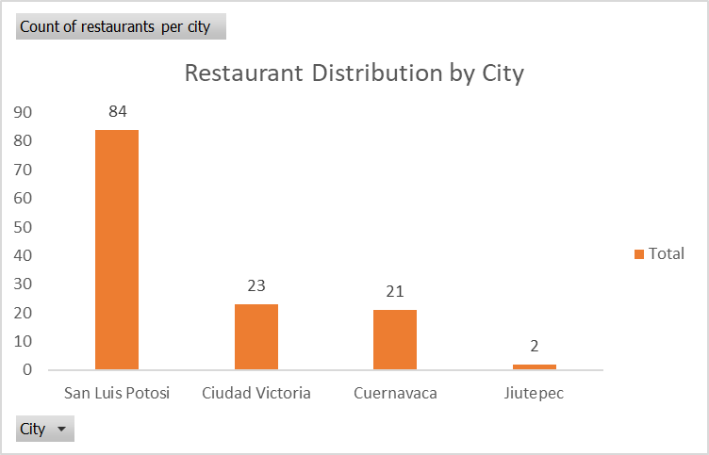
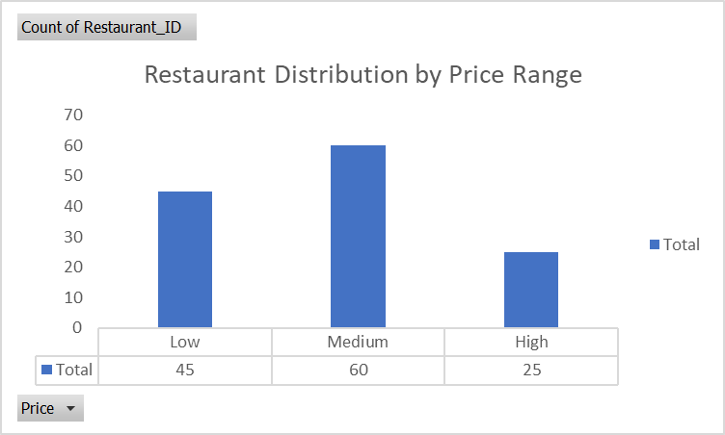

3.3 Demand and Supply Gaps (Question 3)
The analysis reveals several demand and supply gaps in the restaurant market. Restaurants are heavily concentrated in certain cities, indicating potential opportunities in under-served locations. Most restaurants operate within the low to mid-price range, suggesting limited options for premium dining. Smoking preferences also reveal a niche in the market that is currently under-represented. Furthermore, the relatively small number of highly rated restaurants highlights a quality gap, which could be addressed through improved services and food consistency to better meet customers' demand and satisfaction.

4. Investment Considerations (Question 4)
If investing in a restaurant, key characteristics would include location in an under-served but growing area, a mid-priced positioning to appeal to the largest customer segment, and consistently high customer ratings, with quality food, excellent services that aligns with customer preferences to ensure long-term success.

5. Conclusion
The analysis highlights key trends in customer behavior and market structure within the restaurant industry. These insights can support informed decision-making for restaurant development and investment.

